Android9 拨号流程

G:\code-pj\source\t710\packages\apps\Dialer\java\com\android

拨号应用：

G:\code-pj\source\t710\packages\apps\Dialer

Telecom : InCallController: Components updated: [ComponentInfo{com.android.dialer/com.android.incallui.InCallServiceImpl}]

am_set_resumed_activity: [0,com.android.dialer/com.android.incallui.InCallActivity,minimalResumeActivityLocked]

Dialer : AudioModeProvider.getApproximatedAudioRoute - Routing to earpiece

D ImsPhoneCallTracker: [0] updatePhoneState pendingMo = DIALING, fg= DIALING(1), bg= IDLE(0)

BroadcastQueue: Finished with ordered broadcast BroadcastRecord{203b078 u0 android.intent.action.NEW_OUTGOING_CALL} receivers:(2) take

Telecom : Logging.Events: Non-call EVENT: BIND_CS, ComponentInfo{com.android.phone/com.android.services.telephony.TelephonyConnectionService}: NOCBIR.oR->CSFM.rF@Aq

Telecom : CallerInfoLookupHelper: CI query for handle tel:*** **** **77 has completed; notifying all listeners.: TSI.pC->CILH.sL->CILH.oQC@AqU

I Telecom : CallerInfoLookupHelper: CI query for handle tel:*********77 has completed; notifying all listeners.: TSI.pC->CILH.sL->CILH.oQC@AqU

I Telecom : Call: CallerInfo received for tel:*********77: com.android.internal.telephony.CallerInfo@5145e31 { name null, phoneNumber non-null }: TSI.pC->CI

I Telecom : Event: RecordEntry TC@2: START_CONNECTION, tel:*********77: SBC.oSC@Aqw

Telecom : CallerInfoLookupHelper: CI query for handle tel:***86 has completed; notifying all listeners.: TSI.pC->CILH.sL->CILH.oQC@AKI

Dialer : AudioModeProvider.getApproximatedAudioRoute - Routing to earpiece

Dialer : InCallPresenter.onCallListChange - Phone switching state: NO_CALLS -> NO_CALLS

ImsPhoneCallTracker: [0] isUsim = true isUtEnable = true

GsmCdmaPhone: type = 0

GsmCdmaPhone: [GsmCdmaPhoneEx] useImsForCall=true, useImsForEmergency=false, useImsForUt=true, isUt=false, isWpsCall=false, allowWpsOverIms=true, imsPhone=Handler (com.android.internal.telephony.imsphone.ImsPhone) {84178c1}, imsPhone.isVolteEnabled()=true, imsPhone.isVowifiEnabled()=false, imsPhone.isVideoEnabled()=true, imsPhone.getServiceState().getState()=0

[InCallUIHdAudioHelper]: getInstance()

GsmCdmaPhone: [GsmCdmaPhoneEx] Trying IMS PS call

am_on_create_called: [0,com.android.incallui.InCallActivity,performCreate]

Dialer : InCallFragment.onCreateView

ImsService: createCallSession-> startVoLteCall

RIL : onRequest: DIAL radioState = RADIO_ON

REQ_THDS: get Channel1

RIL-AT : Channel1: AT> ATD10086;//打10086

ImsPhoneCallTracker: [0] updatePhoneState pendingMo = DIALING, fg= DIALING(1), bg= IDLE(0)

audio_hw_voice: Start pcm_modem_ul start

DataPhoneManager[0]: phone0 call start

static struct RIL_Env s_rilEnv = {

RIL_onRequestComplete,

RIL_onUnsolicitedResponse,

RIL_requestTimedCallback,

RIL_onRequestAck

};

ImsPhoneCallTracker.java (frameworks\opt\telephony\src\java\com\android\internal\telephony\imsphone) 179838 2022/2/28

updatePhoneState

Rild.c (hardware\ril\rild) 7045 2022/2/28

Main

--->rilLibPath = argv[i + 1]; //读取ril库路径strcmp(argv[i], "-l")

--->hasLibArgs = 1;//strcmp(argv[i], "--" 库参数

--->clientId = argv[i+1];

--->property_get(LIB_PATH_PROPERTY, libPath, NULL)//如何rilLibPath没有设置 根据属性控制

--->dlHandle = dlopen(rilLibPath, RTLD_NOW); //打开库并加载

--->RIL_startEventLoop();

Ril.cpp (hardware\ril\libril) 48228 2022/2/28

--->pthread_create(&s_tid_dispatch, &attr, eventLoop, NULL);

--->eventLoop

--->ril_event_init();

Ril.cpp (hardware\ril\libril) 48228 2022/2/28

--->FD_ZERO(&readFds);

init_list(&timer_list);

init_list(&pending_list);

memset(watch_table, 0, sizeof(watch_table));

--->s_started = 1;

--->pipe(filedes);

--->s_fdWakeupRead = filedes[0];

--->s_fdWakeupWrite = filedes[1];

--->fcntl(s_fdWakeupRead, F_SETFL, O_NONBLOCK);

---> ril_event_set (&s_wakeupfd_event, s_fdWakeupRead, true,

processWakeupCallback, NULL);

Ril.cpp (hardware\ril\libril) 48228 2022/2/28

---> ev->fd = fd;--->s_fdWakeupRead

**--->ev->index = -1;**

**--->ev->persist = persist; --->true**

**--->ev->func = func;--->**processWakeupCallback

--->do {

ret = read(s_fdWakeupRead, &buff, sizeof(buff));

--->do {

ret = read(s_fdWakeupRead, &buff, sizeof(buff));

} while (ret > 0 || (ret < 0 && errno == EINTR));

} while (ret > 0 || (ret < 0 && errno == EINTR));

**--->ev->param = param; --->null**

**--->fcntl(fd, F_SETFL, O_NONBLOCK);**

---> rilEventAddWakeup (&s_wakeupfd_event);

--->ril_event_add(ev);

--->for (int i = 0; i < MAX_FD_EVENTS; i++) {

if (watch_table[i] == NULL) {

watch_table[i] = ev;

ev->index = i;

dlog("~~~~ added at %d ~~~~", i);

dump_event(ev);

FD_SET(ev->fd, &readFds);

if (ev->fd >= nfds) nfds = ev->fd+1;

dlog("~~~~ nfds = %d ~~~~", nfds);

break;

}

}

--->triggerEvLoop();

--->do {

ret = write (s_fdWakeupWrite, " ", 1);

} while (ret < 0 && errno == EINTR);

--->ril_event_loop();

Ril_event.cpp (hardware\ril\libril) 10100 2022/2/28

--->for (;;)

--->select(nfds, &rfds, NULL, NULL, ptv);

--->processReadReadies(&rfds, n);

---> for (int i = 0; (i < MAX_FD_EVENTS) && (n > 0); i++) {

struct ril_event * rev = watch_table[i];

if (rev != NULL && FD_ISSET(rev->fd, rfds)) {

addToList(rev, &pending_list);

if (rev->persist == false) {

removeWatch(rev, i);

}

n--;

}

}

---> processTimeouts();

--->firePending();

--->while (ev != &pending_list) {

struct ril_event * next = ev->next;

removeFromList(ev);

ev->func(ev->fd, 0, ev->param);

ev = next;

}

--->rilInit =(const RIL_RadioFunctions *(*)(const struct RIL_Env *, int, char **))dlsym(dlHandle, "RIL_Init");//打开ril库中的RIL_Init函数 通过这个接口调用vendor-ril

--->s_rilenv = env;-->

--->rilUimInit =(const RIL_RadioFunctions *(*)(const struct RIL_Env *, int, char **))dlsym(dlHandle, "RIL_SAP_Init");

--->funcs = rilInit(&s_rilEnv, argc, rilArgv);

--->s_rilenv = env;-->s_rilEnv

--->传入:s_rilEnv

--->RIL_onRequestComplete

--->RIL_onUnsolicitedResponse ---》void RIL_onUnsolicitedResponse(int unsolResponse, const void *data,

--->RIL_requestTimedCallback

--->RIL_onRequestAck

--->ret = pthread_create(&s_tid_mainloop, &attr, mainLoop, NULL);

--->fd = open (s_device_path, O_RDWR);

--->s_closed = 0;

--->ret = at_open(fd, onUnsolicited);

--->RIL_requestTimedCallback(initializeCallback, NULL, &TIMEVAL_0);

--->setRadioState (RADIO_STATE_OFF);

--->at_send_command("AT+CMGF=0", NULL);

--->s_rilenv->RequestTimedCallback(a,b,c)

--->return &s_callbacks;//vendor ril

--->RIL_VERSION

--->onRequest

--->currentState

--->onSupports

--->onCancel

--->getVersion

--->RIL_register(funcs);//funcs=s_callbacks

Ril.cpp (hardware\ril\libril) 48228 2022/2/28

--->memcpy(&s_callbacks, callbacks, sizeof (RIL_RadioFunctions));

--->s_registerCalled = 1;

--->radio::registerService(&s_callbacks, s_commands);--->ril_commands.h

Ril_service.cpp (hardware\ril\libril) 331337 2022/2/28

--->s_vendorFunctions = callbacks;

--->s_commands = commands;

--->configureRpcThreadpool(1, true /* callerWillJoin */);

--->radioService[i]->mSlotId = i;

--->status = radioService[i]->registerAsService(serviceNames[i]);//这里是注册hidl服务

--->RIL_register_socket(rilUimInit, RIL_SAP_SOCKET, argc, rilArgv);

--->rilc_thread_pool();

T710 android10 ril分析：

Impl_ril.c (g:\code-pj\source\t710-android10\t710-android10-ril\rild\impl-ril) 67472 2022/5/30

RIL_Init

--->s_rilEnv = env;

--->requestHandlerInit(processRequest, SIM_COUNT);

--->initStk(&s_stkFunctions);

--->s_stkFunctions

--->onRILRequest

--->requestSetupDataConnection

--->requestDeactiveDataConnection

--->getDefaultBearerNetAccessName

--->getEthNameByCid

--->onUnsolResponse

--->sendPsDataOffToExtData

--->at_set_on_reader_closed(onATReaderClosed);

---> ps_service_init();

--->pthread_create(&tid, &attr, (void *)listenExtDataThread, NULL);

--->pthread_create(&tid, &attr, detectModemState, NULL);

--->pthread_create(&s_mainLoopTid[simId], &attr, mainLoop,

(void *)&s_socketId[simId]);

--->init_channels(socket_id);

--->start_reader(socket_id);

--->pthread_create(&s_readerThread[socket_id].readerTid, &attr,

readerLoop, (void*)&s_socketId[socket_id]);

--->readerLoop

--->select(open_ATchs + 1, &rfds, NULL, NULL, NULL);

--->read(s_fdReaderLoopWakeupRead[socket_id], buf, sizeof(buf));

---> setChannelInitialized(socket_id);

--->pthread_create(&tid, &attr, initializeCallback,

(void *)&s_socketId[socket_id]);

--->setCESQGlobalArray(s_rsrp, s_ecno, s_rscp, s_ber, s_rxlev, s_ss_rsrp);

--->pthread_create(&tid, &attr, (void *)signalProcess, (void *)&s_networkFunctions);

s_networkFunctions

--->onRILRequest

--->onSignalStrengthUnsolResponse

--->setHwVerPorp();

--->return &s_callbacks;

s_callbacks

--->onRequest

--->currentState

--->onSupports

--->onCancel

--->getVersion

--->sendCmdSync

--->initVaribales

--->requestTimedCallback

--->&s_seCallbacks

--->initForSeService

--->getAtrForSeService

--->isCardPresentForSeService

--->transmitForSeService

--->openLogicalChannelForSeService

--->openBasicChannelForSeService

--->closeChannelForSeService

Ril_service.cpp (g:\code-pj\source\t710-android10\t710-android10-ril\rild\libril) 683588 2022/5/30

Ril_services分析

radio::registerService

--->获取服务名：android::RIL_getServiceName()

--->多个sim卡 增加服务名：RIL2_SERVICE_NAME

--->s_vendorFunctions = callbacks;//将vendor ril的接口赋值给vendorFunctions

--->s_commands = commands;//

--->configureRpcThreadpool(1, true /* callerWillJoin */);

---> radioService[i] = new RadioImpl;

--->extRadioService[i] = new ExtRadioImpl;

--->android::status_t status = radioService[i]->registerAsService(serviceNames[i]);//注册为hidl服务 绑定式服务

--->status = extRadioService[i]->registerAsService(serviceNames[i]);

--->status = oemHookService[i]->registerAsService(serviceNames[i]);

Ril.cpp

ril_event_loop

**--->n = select(nfds, &rfds, NULL, NULL, ptv);**

**--->processTimeouts();**

**--->processReadReadies(&rfds, n);**

**--->firePending();**

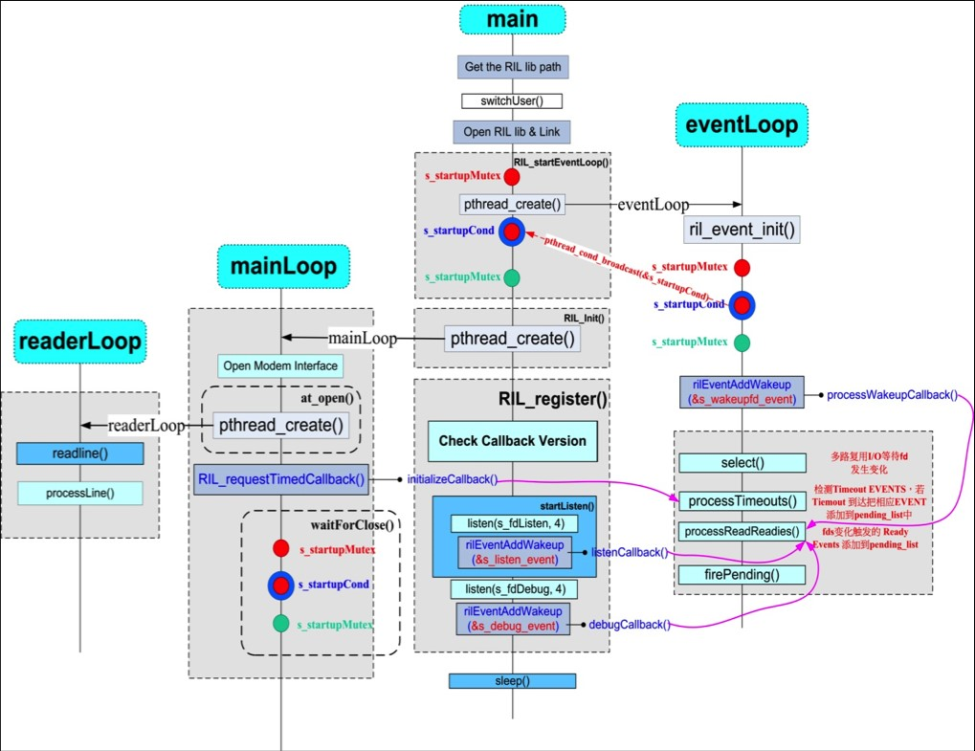

**s_ATSender**

**Ril_mch.cpp (f:\work\2022-work\t710-pad\work\714资料\ril_tt\ril\libril) 216064 2022/8/24**

**Ril_requestAtSender s_ATSender[RIL_DEVICE_MAX_COUNT];**

**RIL_startEventLoop**

**--->for(n = 0; n < RIL_DEVICE_MAX_COUNT; n++) {**

**s_ATSender[n].m_at_ch_name = at_ch_name[n];**

**s_ATSender[n].m_fd = -1; // fix 2011-09-22**

**//RLOGD("%d, %s, n = %d\n",__LINE__,__FUNCTION__, n);**

**}**

**--->for(n = 0; n < (RIL_DEVICE_MAX_COUNT-1); n++) {**

**ret = pthread_create(&(s_ATSender[n].m_thread_id), &attr_request, request_handler_thread, &(s_ATSender[n]));**

**}**

--->**request_handler_thread**

**--->while(1)**

**--->processCommandBuffer(pRI->m_buffer, pRI->m_buff_len);**

**--->p.setData((uint8_t *) buffer, buflen);**

**--->sendResponse(pErr);**

**--->pRI = (RequestInfo *)calloc(1, sizeof(RequestInfo));**

**---> pRI->token = token;**

**--->pRI->pCI = &(s_commands[requestIdx]);**

**--->pRI->pCI->dispatchFunction(p, pRI);**

Android4.4 ril

Rild.c (f:\work\2022-work\t710-pad\work\714资料\anroid4.4\rild) 7980 2022/10/4

int main(int argc, char **argv)

--->switchUser();

--->dlHandle = dlopen(rilLibPath, RTLD_NOW);//打开vendor ril库

//Ril.cpp (f:\work\2022-work\t710-pad\work\714资料\anroid4.4\libril) 130646 2022/10/4

--->RIL_startEventLoop();

--->s_started = 0;

--->pthread_create(&s_tid_dispatch, &attr, eventLoop, NULL);

eventLoop

---> ril_event_init();

--->FD_ZERO(&readFds);

--->init_list(&timer_list);

--->init_list(&pending_list);

--->memset(watch_table, 0, sizeof(watch_table));

--->s_started = 1;

--->pthread_cond_broadcast(&s_startupCond);

--->pthread_mutex_unlock(&s_startupMutex);

--->ret = pipe(filedes);

--->s_fdWakeupRead = filedes[0];

---> s_fdWakeupWrite = filedes[1];

--->fcntl(s_fdWakeupRead, F_SETFL, O_NONBLOCK);

--->ril_event_set (&s_wakeupfd_event, s_fdWakeupRead, true,

processWakeupCallback, NULL);

--->memset(ev, 0, sizeof(struct ril_event));

---> ev->fd = fd;--->s_fdWakeupRead

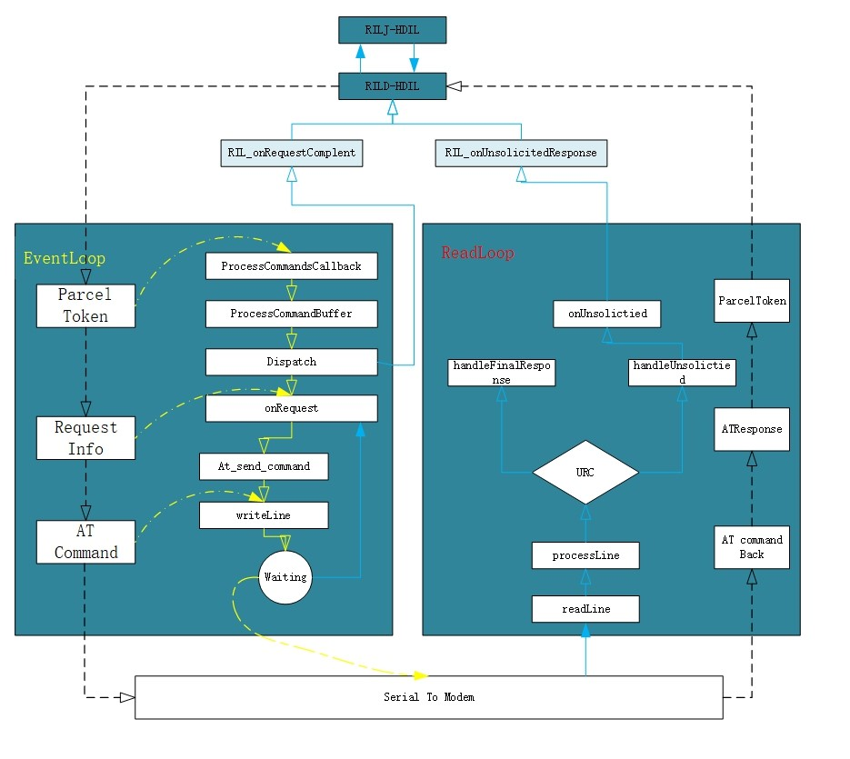

--->ev->index = -1;

--->ev->persist = persist;

--->ev->func = func;--->processWakeupCallback

--->do {

ret = read(s_fdWakeupRead, &buff, sizeof(buff));

} while (ret > 0 || (ret < 0 && errno == EINTR));

--->ev->param = param;

--->fcntl(fd, F_SETFL, O_NONBLOCK);

--->rilEventAddWakeup (&s_wakeupfd_event);

--->ril_event_add(ev);--->s_wakeupfd_event

--->for (int i = 0; i < MAX_FD_EVENTS; i++) {

if (watch_table[i] == NULL) {

watch_table[i] = ev;

ev->index = i;

dlog("~~~~ added at %d ~~~~", i);

dump_event(ev);

FD_SET(ev->fd, &readFds);

if (ev->fd >= nfds) nfds = ev->fd+1;

dlog("~~~~ nfds = %d ~~~~", nfds);

break;

}

}

--->triggerEvLoop();

--->if (!pthread_equal(pthread_self(), s_tid_dispatch)) {

/* trigger event loop to wakeup. No reason to do this,

* if we're in the event loop thread */

do {

ret = write (s_fdWakeupWrite, " ", 1);

} while (ret < 0 && errno == EINTR);

}

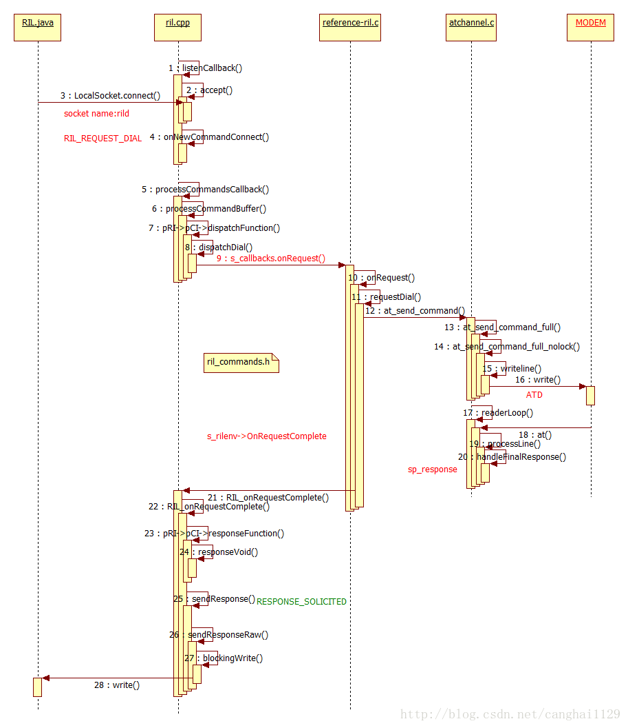

--->ril_event_loop();

--->

for (;;) {

// make local copy of read fd_set

memcpy(&rfds, &readFds, sizeof(fd_set));

if (-1 == calcNextTimeout(&tv)) {

// no pending timers; block indefinitely

dlog("~~~~ no timers; blocking indefinitely ~~~~");

ptv = NULL;

} else {

dlog("~~~~ blocking for %ds + %dus ~~~~", (int)tv.tv_sec, (int)tv.tv_usec);

ptv = &tv;

}

printReadies(&rfds);

n = select(nfds, &rfds, NULL, NULL, ptv);

printReadies(&rfds);

dlog("~~~~ %d events fired ~~~~", n);

if (n < 0) {

if (errno == EINTR) continue;

RLOGE("ril_event: select error (%d)", errno);

// bail?

return;

}

// Check for timeouts

processTimeouts();

--->struct ril_event * tev = timer_list.next;

---> struct ril_event * next;

--->while ((tev != &timer_list) && (timercmp(&now, &tev->timeout, >))) {

// Timer expired

dlog("~~~~ firing timer ~~~~");

next = tev->next;

removeFromList(tev);

addToList(tev, &pending_list);

tev = next;

}

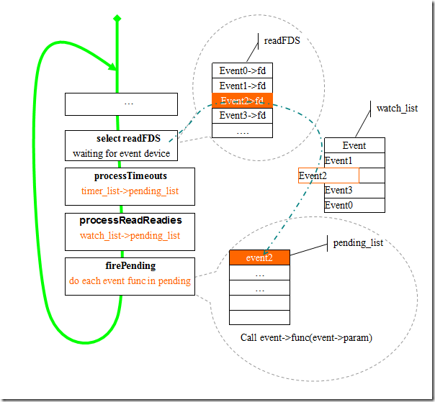

// Check for read-ready

processReadReadies(&rfds, n);

--->for (int i = 0; (i < MAX_FD_EVENTS) && (n > 0); i++) {

struct ril_event * rev = watch_table[i];

if (rev != NULL && FD_ISSET(rev->fd, rfds)) {

addToList(rev, &pending_list);

if (rev->persist == false) {

removeWatch(rev, i);

}

n--;

}

}

// Fire away

firePending();

--->struct ril_event * ev = pending_list.next;

while (ev != &pending_list) {

struct ril_event * next = ev->next;

removeFromList(ev);

ev->func(ev->fd, 0, ev->param);

ev = next;

}

}

获取vendor ril库中的RIL_Init接口

--->rilInit = (const RIL_RadioFunctions *(*)(const struct RIL_Env *, int, char **))dlsym(dlHandle, "RIL_Init");

--->funcs = rilInit(&s_rilEnv, argc, rilArgv);//获取vendor ril的func ，vendor ril的初始化参数s_rilEnv

Reference-ril.c (f:\work\2022-work\t710-pad\work\714资料\anroid4.4\reference-ril) 103111 2022/10/4

--->RIL_Init

--->ret = pthread_create(&s_tid_mainloop, &attr, mainLoop, NULL);

--->mainLoop

--->fd = open (s_device_path, O_RDWR);

--->ret = at_open(fd, onUnsolicited);

--->RIL_requestTimedCallback(initializeCallback, NULL, &TIMEVAL_0);

---> s_rilenv->RequestTimedCallback(a,b,c) --->initializeCallback

--->setRadioState (RADIO_STATE_OFF);

---> at_send_command("AT+CGEREP=1,0", NULL);

--->setRadioState (RADIO_STATE_ON);

---> waitForClose();

---> return &s_callbacks;

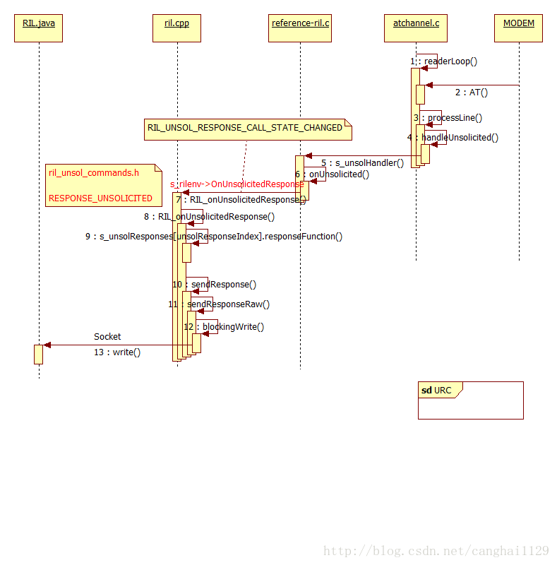

--->RIL_VERSION

--->onRequest

--->currentState

--->onSupports

--->onCancel

--->getVersion

--->RIL_register(funcs);

//Ril.cpp (f:\work\2022-work\t710-pad\work\714资料\anroid4.4\libril) 130646 2022/10/4

RIL_register

--->memcpy(&s_callbacks, callbacks, sizeof (RIL_RadioFunctions));//将vendor ril的callback函数给s_callbacks

s_callbacks.onRequest(request, data, len, pRI);调用的是vendor ril中的文件

---> s_registerCalled = 1;

--->if (s_started == 0) {

RIL_startEventLoop();

--->pthread_create(&s_tid_dispatch, &attr, eventLoop, NULL);

--->eventLoop

--->ret = pipe(filedes);

--->s_fdWakeupRead = filedes[0];

--->s_fdWakeupWrite = filedes[1];

--->fcntl(s_fdWakeupRead, F_SETFL, O_NONBLOCK);

--->ril_event_set (&s_wakeupfd_event, s_fdWakeupRead, true,

processWakeupCallback, NULL);

--->rilEventAddWakeup (&s_wakeupfd_event);

--->ril_event_loop();

}

--->s_fdListen = android_get_control_socket(SOCKET_NAME_RIL);//创建socket

--->ret = listen(s_fdListen, 4);

--->ril_event_set (&s_listen_event, s_fdListen, false,

listenCallback, NULL);

--->listenCallback

---> s_fdCommand = accept(s_fdListen, (sockaddr *) &peeraddr, &socklen);

--->err = getsockopt(s_fdCommand, SOL_SOCKET, SO_PEERCRED, &creds, &szCreds);

--->ret = fcntl(s_fdCommand, F_SETFL, O_NONBLOCK);

--->p_rs = record_stream_new(s_fdCommand, MAX_COMMAND_BYTES);

---> ril_event_set (&s_commands_event, s_fdCommand, 1,

processCommandsCallback, p_rs);

--->processCommandsCallback

--->for (;;)

--->ret = record_stream_get_next(p_rs, &p_record, &recordlen);

--->processCommandBuffer(p_record, recordlen);

--->pRI->token = token;

--->pRI->pCI = &(s_commands[request]);//根据request 获取ril_commands.h的命令

--->pRI->p_next = s_pendingRequests;

--->s_pendingRequests = pRI;

--->pRI->pCI->dispatchFunction(p, pRI);

---->调用vendor ril的函数

--->rilEventAddWakeup (&s_commands_event);

--->onNewCommandConnect();

--->rilEventAddWakeup (&s_listen_event);

Socket :

#define SOCKET_NAME_RIL "rild"

ril_event有5个

static struct ril_event s_commands_event;

static struct ril_event s_wakeupfd_event;

static struct ril_event s_listen_event;

static struct ril_event s_wake_timeout_event;

static struct ril_event s_debug_event;

Ril_event.cpp (f:\work\2022-work\t710-pad\work\714资料\anroid4.4\libril) 10437 2022/10/4

static struct ril_event * watch_table[MAX_FD_EVENTS];

static struct ril_event timer_list;

static struct ril_event pending_list;

714 天通 ril:

F:\work\2022-work\t710-pad\work\714资料\ril_tt\ril\rild\rild.c

int main(int argc, char **argv)

--->int rilID = -1;

--->根据-s设置相关属性

--->switch (index) {

case 0:

property_set(RILD_MSMS_SIM_COUNT_PROPERTY, &ch);

break;

case 1:

property_set(RILD_MSMS_STANDBY_COUNT_PROPERTY, &ch);

break;

case 2:

property_set(RILD_MSMS_COMMUNICATION_COUNT_PROPERTY, &ch);

break;

}

--->设置Modem类型

--->if(property_get(PROPERTY_PERSIST_SYS_XT_MODEM_TYPE, property_value_a, NULL)) {

g_modemtype = property_value_a[0] - '0';

}

--->dlHandle = dlopen(rilLibPath, RTLD_NOW);

--->RIL_startEventLoop_ex(rilID);

Ril_mch.cpp (f:\work\2022-work\t710-pad\work\714资料\ril_tt\ril\libril) 216064 2022/8/24

--->sprintf(socket_ril, "%s%d", SOCKET_NAME_RIL, rilID);

--->memcpy(&s_callbacks, callbacks, sizeof (RIL_RadioFunctions));

--->s_registerCalled = 1;

--->if (s_started == 0) {

-RIL_startEventLoop_ex(rilID);

--->for(n = 0; n < RIL_DEVICE_MAX_COUNT; n++) {

if(0 == mrilID) {

s_ATSender[n].m_at_ch_name = at_ch_name[n];

}

else {

s_ATSender[n].m_at_ch_name = at_ch_name[n+RIL_DEVICE_MAX_COUNT];

}

}

--->pthread_create(&(s_ATSender[0].m_thread_id), &attr_request, request_handler_thread, &(s_ATSender[0]));

--->request_handler_thread(void *param)

--->Ril_requestAtSender *mATSender = (Ril_requestAtSender *)param;

--->//接收multiRequstNotify 通知

---> processCommandBuffer(pRI->m_buffer, pRI->m_buff_len);

--->pRI->token = token;

--->pRI->pCI = &(s_commands[requestIdx]);

--->pRI->pCI->dispatchFunction(p, pRI);--->vendor ril处理

}

--->// start listen socket

--->s_fdListen = android_get_control_socket(socket_ril);

--->ret = listen(s_fdListen, 4);

--->ril_event_set (&s_listen_event, s_fdListen, false,

listenCallback, NULL);

--->rilEventAddWakeup (&s_listen_event);

--->rilInit = (const RIL_RadioFunctions *(*)(const struct RIL_Env *, int, char **))dlsym(dlHandle, "RIL_Init");

--->shutdownLmiDevices = (void (*)(int))dlsym(dlHandle, "ata_ps_close_lmi_in_shutdown");

--->funcs = rilInit(&s_rilEnv, argc, rilArgv);

--->signal(RESET_PROCESS_SIGNAL, signal_treatment);

--->RIL_register_ex(funcs, rilID);

---> memcpy(&s_callbacks, callbacks, sizeof (RIL_RadioFunctions));

--->s_registerCalled = 1;

--->if (s_started == 0) {

RIL_startEventLoop_ex(rilID);

}

--->s_fdListen = android_get_control_socket(socket_ril);

--->ret = listen(s_fdListen, 4);

--->ril_event_set (&s_listen_event, s_fdListen, false,

listenCallback, NULL);

--->s_fdCommand = accept(s_fdListen, (sockaddr *) &peeraddr, &socklen);

---> err = getsockopt(s_fdCommand, SOL_SOCKET, SO_PEERCRED, &creds, &szCreds);

--->ret = fcntl(s_fdCommand, F_SETFL, O_NONBLOCK);

--->p_rs = record_stream_new(s_fdCommand, MAX_COMMAND_BYTES);

--->ril_event_set (&s_commands_event, s_fdCommand, 1,

processCommandsCallback, p_rs);

--->rilEventAddWakeup (&s_commands_event);

--->onNewCommandConnect();

--->rilEventAddWakeup (&s_listen_event);

--->create_parse_plmn_th(rilID);

--->

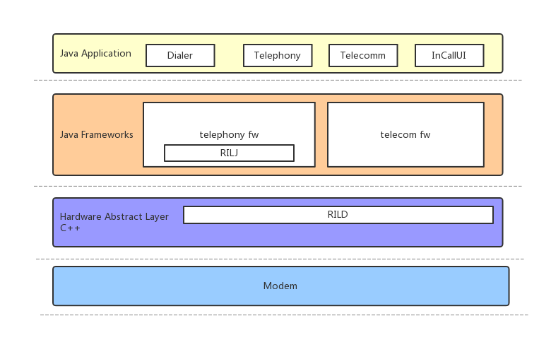

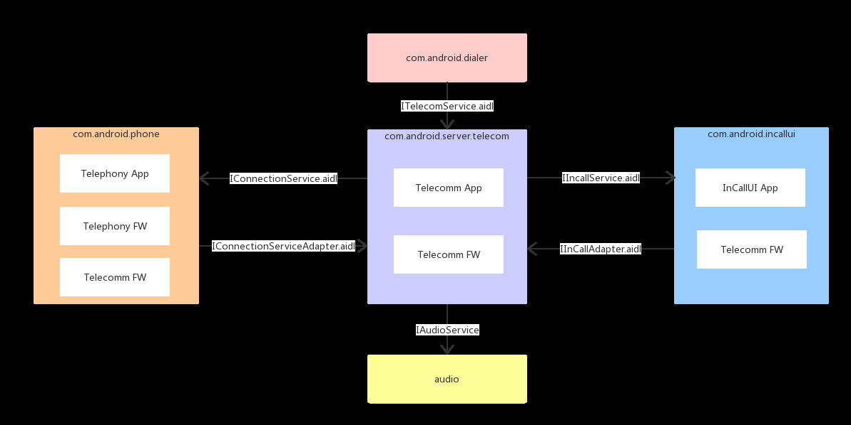

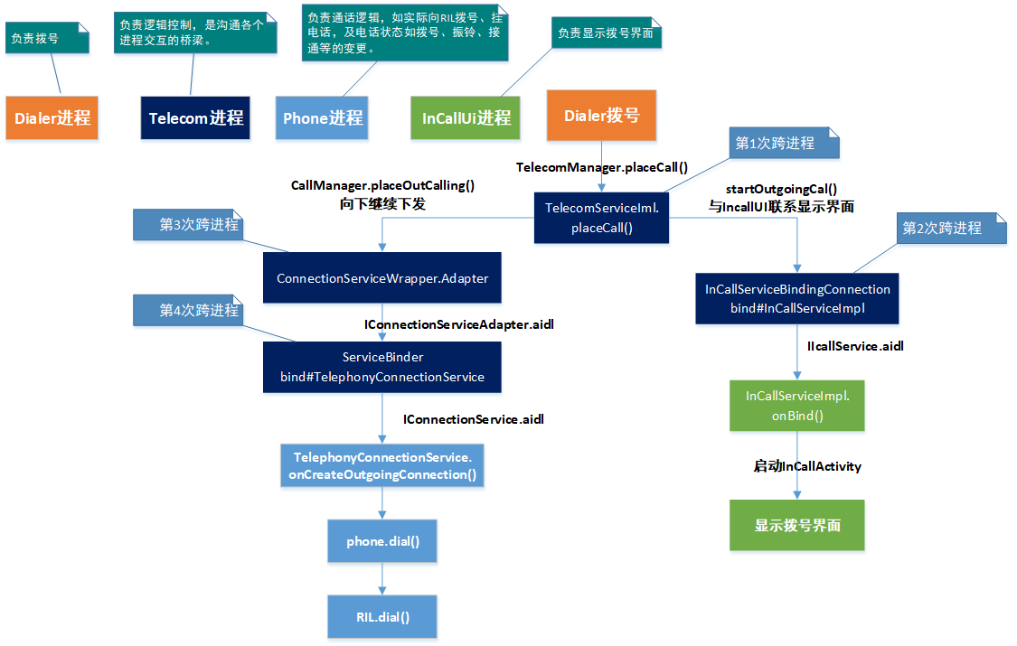

DialpadFragment.java (packages\apps\dialer\java\com\android\dialer\dialpadview) 109651 2022/2/28

拨号按键处理:

public void onClick(View view) {

int resId = view.getId();

if (resId == R.id.dialpad_floating_action_button) {

view.performHapticFeedback(HapticFeedbackConstants.VIRTUAL_KEY);

/* SPRD: add for bug731278 & 782352 & 897080 @{ */

if (mIsDualVoLTEActive) {

if (mIsSecSimIncall && !ImsManagerEx.isReadyForDualActiveCall()) {

Toast.makeText(getActivity(),

R.string.toast_not_dual_volte_regist, Toast.LENGTH_SHORT).show();

return;

}

handleDialButtonPressed(INDEX_SIM1);

} else {

handleDialButtonPressed();

}

} else if (resId == R.id.dialpad_floating_action_secondary_button) {

view.performHapticFeedback(HapticFeedbackConstants.VIRTUAL_KEY);

if (mIsFirstSimIncall && !ImsManagerEx.isReadyForDualActiveCall()) {

Toast.makeText(getActivity(),

R.string.toast_not_dual_volte_regist, Toast.LENGTH_SHORT).show();

return;

}

handleDialButtonPressed(INDEX_SIM2);

/* @} */

} else if (resId == R.id.deleteButton) {

keyPressed(KeyEvent.KEYCODE_DEL);

} else if (resId == R.id.digits) {

if (!isDigitsEmpty()) {

digits.setCursorVisible(true);

}

} else if (resId == R.id.dialpad_overflow) {

overflowPopupMenu.show();

/* SPRD: FEATURE_WAIT_PAUSE_ON_LONG_CLICK @{ */

} else if (resId == R.id.pound) {

if (!digitsFilledByIntent && getActivity() != null && digits != null

&& digits.getText() != null) {

SpecialCharSequenceMgr.handleAdnEntry(getActivity(), digits.getText()

.toString(), digits);

}

/* @} */

} else {

LogUtil.w("DialpadFragment.onClick", "Unexpected event from: " + view);

}

}

---->

DialpadFragment.java (packages\apps\dialer\java\com\android\dialer\dialpadview) 109651 2022/2/28

private void handleDialButtonPressed(int phoneId) {

List<PhoneAccountHandle> subscriptionAccountHandles =

PhoneAccountUtils.getSubscriptionPhoneAccounts(getActivity());

PhoneAccountHandle account;

int size = 0;

if (subscriptionAccountHandles != null) {

size = subscriptionAccountHandles.size();

}

Log.i(TAG, "handleDialButtonPressed->phoneId:" + phoneId + " size:" + size);

if (subscriptionAccountHandles != null && size > 1 && phoneId < size && mIsDoubleSim) {

account = subscriptionAccountHandles.get(phoneId);

} else {

handleDialButtonPressed();

return;

}

if (isDigitsEmpty()) {

handleDialButtonClickWithEmptyDigits();

} else {

final String number = digits.getText().toString();

if (number != null

&& !TextUtils.isEmpty(prohibitedPhoneNumberRegexp)

&& number.matches(prohibitedPhoneNumberRegexp)) {

Log.i(TAG, "The phone number is prohibited explicitly by a rule.");

if (getActivity() != null) {

DialogFragment dialogFragment = ErrorDialogFragment.newInstance(

R.string.dialog_phone_call_prohibited_message);

dialogFragment.show(getFragmentManager(), "phone_prohibited_dialog");

}

clearDialpad();

} else {

final Intent intent = new CallIntentBuilder(number, CallInitiationType.Type.DIALPAD)

.setPhoneAccountHandle(account)

.build();

DialerUtils.startActivityWithErrorToast(getActivity(), intent);

clearDialpad();

}

}

}

/* @} */

---->

DialerUtils.java (packages\apps\dialer\java\com\android\dialer\util) 23969 2022/2/28

public static void startActivityWithErrorToast(Context context, Intent intent) {

/* SPRD: Add feature of low battery for Reliance @{ */

if (intent.getExtras() != null && VideoProfile.isBidirectional(intent.getExtras().getInt(

TelecomManager.EXTRA_START_CALL_WITH_VIDEO_STATE))

&& CallUtil.isBatteryLow(context)) {

CallUtil.showLowBatteryDialDialog(context, intent, true);

} else {

startActivityWithErrorToast(context, intent,

R.string.activity_not_available);

}/* @} */

}

--->DialerUtils.java (packages\apps\dialer\java\com\android\dialer\util) 23969 2022/2/28

public static void startActivityWithErrorToast(

final Context context, final Intent intent, int msgId) {

try {

if ((Intent.ACTION_CALL.equals(intent.getAction()))) {

// All dialer-initiated calls should pass the touch point to the InCallUI

Point touchPoint = TouchPointManager.getInstance().getPoint();

if (touchPoint.x != 0 || touchPoint.y != 0) {

Bundle extras;

// Make sure to not accidentally clobber any existing extras

if (intent.hasExtra(TelecomManager.EXTRA_OUTGOING_CALL_EXTRAS)) {

extras = intent.getParcelableExtra(TelecomManager.EXTRA_OUTGOING_CALL_EXTRAS);

} else {

extras = new Bundle();

}

extras.putParcelable(TouchPointManager.TOUCH_POINT, touchPoint);

intent.putExtra(TelecomManager.EXTRA_OUTGOING_CALL_EXTRAS, extras);

}

if (shouldWarnForOutgoingWps(context, intent.getData().getSchemeSpecificPart())) {

LogUtil.i(

"DialUtils.startActivityWithErrorToast",

"showing outgoing WPS dialog before placing call");

AlertDialog.Builder builder = new AlertDialog.Builder(context);

builder.setMessage(R.string.outgoing_wps_warning);

builder.setPositiveButton(

R.string.dialog_continue,

new OnClickListener() {

@Override

public void onClick(DialogInterface dialog, int which) {

placeCallOrMakeToast(context, intent);

}

});

builder.setNegativeButton(android.R.string.cancel, null);

builder.create().show();

} else {

placeCallOrMakeToast(context, intent);

}

} else {

context.startActivity(intent);

}

} catch (ActivityNotFoundException e) {

Toast.makeText(context, msgId, Toast.LENGTH_SHORT).show();

/**UNISOC:modify for the bug 943770 @{*/

} catch(SecurityException e) {

Toast.makeText(context, R.string.activity_not_security, Toast.LENGTH_SHORT).show();

}

/**@}*/

}

TelecomUtil.java (packages\apps\dialer\java\com\android\dialer\telecom) 15212 2022/2/28

public static boolean placeCall(Context context, Intent intent) {

// UNISOC: add for bug917377 982631

Uri handle = intent.getData();

boolean isEmergency = PhoneNumberUtils.isEmergencyNumber(handle == null ? "" : handle.getSchemeSpecificPart());

if (!isEmergency && CallList.getInstance().getIncomingCall() != null) {

Toast.makeText(context, R.string.call_cannot_be_sent, Toast.LENGTH_SHORT).show();

return false;

}

if (hasCallPhonePermission(context)) {

getTelecomManager(context).placeCall(intent.getData(), intent.getExtras());

return true;

}

return false;

}

TelecomManager.java (frameworks\base\telecomm\java\android\telecom) 76994 2022/2/28

public boolean isInManagedCall() {

try {

if (isServiceConnected()) {

return getTelecomService().isInManagedCall(mContext.getOpPackageName());

}

} catch (RemoteException e) {

Log.e(TAG, "RemoteException calling isInManagedCall().", e);

}

return false;

}

private ITelecomService getTelecomService() {

if (mTelecomServiceOverride != null) {

return mTelecomServiceOverride;

}

return ITelecomService.Stub.asInterface(ServiceManager.getService(Context.TELECOM_SERVICE));

}

InCallService.java (frameworks\base\telecomm\java\android\telecom) 33066 2022/2/28

class InCallServiceImpl extends InCallService

类InCallServiceImpl 继承 InCallService

服务如何绑定 如何通信

InCallServiceImpl 的作用：接收Telecom组件的的电话更新 服务绑定telecom

public class InCallServiceImpl extends InCallService {

private NewReturnToCallController newReturnToCallController;

private CallList.Listener feedbackListener;

private SpeakEasyCallManager speakEasyCallManager;

@Override

public void onBringToForeground(boolean showDialpad) {

Trace.beginSection("InCallServiceImpl.onBringToForeground");

InCallPresenter.getInstance().onBringToForeground(showDialpad);

Trace.endSection();

}

@Override

public void onCallAdded(Call call) {

Trace.beginSection("InCallServiceImpl.onCallAdded");

InCallPresenter.getInstance().onCallAdded(call);

Trace.endSection();

}

@Override

public IBinder onBind(Intent intent) {

Trace.beginSection("InCallServiceImpl.onBind");

final Context context = getApplicationContext();

final ContactInfoCache contactInfoCache = ContactInfoCache.getInstance(context);

AudioModeProvider.getInstance().initializeAudioState(this);

InCallPresenter.getInstance()

.setUp(

context,

CallList.getInstance(),

new ExternalCallList(),

new StatusBarNotifier(context, contactInfoCache),

new ExternalCallNotifier(context, contactInfoCache),

contactInfoCache,

new ProximitySensor(

context, AudioModeProvider.getInstance(), new AccelerometerListener(context)),

new FilteredNumberAsyncQueryHandler(context));

InCallPresenter.getInstance().onServiceBind();

InCallPresenter.getInstance().maybeStartRevealAnimation(intent);

TelecomAdapter.getInstance().setInCallService(this);

if (NewReturnToCallController.isEnabled(this)) {

newReturnToCallController =

new NewReturnToCallController(this, ContactInfoCache.getInstance(context));

}

feedbackListener = FeedbackComponent.get(context).getCallFeedbackListener();

CallList.getInstance().addListener(feedbackListener);

IBinder iBinder = super.onBind(intent);

Trace.endSection();

return iBinder;

}

}

启动服务:

启动服务方式一:

Intent intentOne = new Intent(this, TestOneService.class);

startService(intentOne);

启动服务方式二:

Intent intent = new Intent(this, TestTwoService.class);

intent.putExtra("from", "ActivityB");

bindService(intent, conn, BIND_AUTO_CREATE);

Class InCallServiceImpl 的绑定:

UiCallManager.java (packages\apps\car\dialer\src\com\android\car\dialer\telecom) 28334 2022/2/28

private UiCallManager(Context context) {

Intent intent = new Intent(context, InCallServiceImpl.class);

intent.setAction(InCallServiceImpl.ACTION_LOCAL_BIND);

context.bindService(intent, mInCallServiceConnection, Context.BIND_AUTO_CREATE);

}

Class:TelecomServiceImpl

--->interface:SubscriptionManagerAdapter //这是一个接口 实现一个方法：**getDefaultVoiceSubId**

**--->getDefaultVoiceSubId();**

**--->class:SubscriptionManagerAdapterImpl 继承SubscriptionManagerAdapter接口 并具体实现该接口**

**public int getDefaultVoiceSubId() {**

**return SubscriptionManager.getDefaultVoiceSubscriptionId();**

**}**

**---> private final ITelecomService.Stub mBinderImpl = new ITelecomService.Stub() { //对服务的具体实现**

**--->getDefaultOutgoingPhoneAccount**

**--->getUserSelectedOutgoingPhoneAccount**

**--->setUserSelectedOutgoingPhoneAccount**

**--->getCallCapablePhoneAccounts**

**--->getSelfManagedPhoneAccounts**

**--->getPhoneAccountsSupportingScheme**

**--->getPhoneAccountsForPackage**

**--->getPhoneAccount**

**--->getAllPhoneAccountsCount**

**--->getAllPhoneAccounts**

**--->getAllPhoneAccountHandles**

**--->getSimCallManager**

**--->getSimCallManagerForUser**

**--->registerPhoneAccount**

**--->unregisterPhoneAccount**

**--->clearAccounts**

**--->isVoiceMailNumber**

**--->getVoiceMailNumber**

**--->getLine1Number**

**--->silenceRinger**

**--->getDefaultPhoneApp**

**--->getDefaultDialerPackage**

**--->getSystemDialerPackage**

**--->isInCall**

**--->isInManagedCall**

**--->isRinging**

**--->getCallState**

**--->endCall**

**--->acceptRingingCall**

**--->acceptRingingCallWithVideoState**

**--->showInCallScreen**

**--->cancelMissedCallsNotification**

**--->handlePinMmi**

**--->handlePinMmiForPhoneAccount**

**--->getAdnUriForPhoneAccount**

**--->isTtySupported**

**---->getCurrentTtyMode**

**--->addNewIncomingCall**

**--->acceptHandover**

**--->addNewUnknownCall**

**--->placeCall**

**--->enablePhoneAccount**

**--->setDefaultDialer**

**--->TelecomAnalytics**

**--->createManageBlockedNumbersIntent**

**--->isOutgoingCallPermitted**

**--->waitOnHandlers**

**--->**

**}**

enforceAnswerCallPermission

enforceAcceptHandoverPermission

TelecomServiceImpl类的实例://完成初始化工作

public TelecomServiceImpl(

Context context,

CallsManager callsManager,

PhoneAccountRegistrar phoneAccountRegistrar,

CallIntentProcessor.Adapter callIntentProcessorAdapter,

UserCallIntentProcessorFactory userCallIntentProcessorFactory,

DefaultDialerCache defaultDialerCache,

SubscriptionManagerAdapter subscriptionManagerAdapter,

TelecomSystem.SyncRoot lock) {

mContext = context;

mAppOpsManager = (AppOpsManager) mContext.getSystemService(Context.APP_OPS_SERVICE);

mPackageManager = mContext.getPackageManager();

mCallsManager = callsManager;

mLock = lock;

mPhoneAccountRegistrar = phoneAccountRegistrar;

mUserCallIntentProcessorFactory = userCallIntentProcessorFactory;

mDefaultDialerCache = defaultDialerCache;

mCallIntentProcessorAdapter = callIntentProcessorAdapter;

mSubscriptionManagerAdapter = subscriptionManagerAdapter;

}

public ITelecomService.Stub getBinder() {

return mBinderImpl;//有完成具体方法的实现

}

--->isPhoneAccountHandleVisibleToCallingUser

--->isCallerSystemApp

--->isPackageSystemApp

--->acceptRingingCallInternal

--->endCallInternal

--->enforcePhoneAccountIsRegisteredEnabled

--->enforcePhoneAccountModificationForPackage

--->enforcePermissionOrPrivilegedDialer

--->enforceCallingPackage

--->enforceConnectionServiceFeature

--->

private TelephonyManager getTelephonyManager() {

return (TelephonyManager) mContext.getSystemService(Context.TELEPHONY_SERVICE);

}

TelecomService.java (packages\services\telecomm\src\com\android\server\telecom\components) 10447 2022/2/28

TelecomService.java (packages\services\telecomm\src\com\android\server\telecom\components) 10447 2022/2/28

Class : public class TelecomService extends Service implements TelecomSystem.Component: 作用:Implementation of the ITelecom interface.

{

public IBinder onBind(Intent intent) {

Log.d(this, "onBind");

initializeTelecomSystem(this);

synchronized (getTelecomSystem().getLock()) {

return getTelecomSystem().getTelecomServiceImpl().getBinder(); //实例化TelecomServiceImpl

}

}

static void initializeTelecomSystem(Context context) {

elecomSystem.setInstance(

new TelecomSystem(

---->new MissedCallNotifierImpl.MissedCallNotifierImplFactory()

--->new CallerInfoAsyncQueryFactory()

--->new HeadsetMediaButtonFactory()

--->new ProximitySensorManagerFactory()

--->new InCallWakeLockControllerFactory()

--->new CallAudioManager.AudioServiceFactory()

--->new BluetoothPhoneServiceImpl.BluetoothPhoneServiceImplFactory()

--->new ConnectionServiceFocusManager

.ConnectionServiceFocusManagerFactory()

--->

)

)

}

public TelecomSystem getTelecomSystem() {

return TelecomSystem.getInstance();

}

}

TelecomSystem.java (packages\services\telecomm\src\com\android\server\telecom) 15832 2022/2/28

public class TelecomSystem {

public interface Component { //这个接口需要由继承的类去实现

TelecomSystem getTelecomSystem();

}

private static final IntentFilter DIALER_SECRET_CODE_FILTER;//暗码

public static TelecomSystem getInstance() {

return INSTANCE;

}

public static void setInstance(TelecomSystem instance) {

if (INSTANCE != null) {

Log.w("TelecomSystem", "Attempt to set TelecomSystem.INSTANCE twice");

}

Log.i(TelecomSystem.class, "TelecomSystem.INSTANCE being set");

INSTANCE = instance;

}

public TelecomSystem(){

--->new DefaultDialerCache.DefaultDialerManagerAdapterImpl();

---> new DefaultDialerCache(mContext,

defaultDialerAdapter, mLock);

--->new PhoneAccountRegistrar(mContext, defaultDialerCache,

--->new ContactsAsyncHelper(

--->new BluetoothDeviceManager(mContext

--->new BluetoothRouteManager(mContext, mLock,

--->new BluetoothStateReceiver(

bluetoothDeviceManager, bluetoothRouteManager);

--->wiredHeadsetManager = new WiredHeadsetManager(mContext);

--->systemStateProvider = new SystemStateProvider(mContext);

--->emergencyCallHelper = new EmergencyCallHelper(mContext,

mContext.getResources().getString(R.string.ui_default_package), timeoutsAdapter);

--->InCallControllerFactory inCallControllerFactory = new InCallControllerFactory() {

----> return new InCallController(context, lock, callsManager, systemStateProvider,

defaultDialerCache, timeoutsAdapter, emergencyCallHelper, clockProxy);

}

}

mCallsManager = new CallsManager;

incomingCallNotifier.setCallsManagerProxy(new IncomingCallNotifier.CallsManagerProxy()

--->mCallsManager.setIncomingCallNotifier(mIncomingCallNotifier);

--->mRespondViaSmsManager = new RespondViaSmsManager(mCallsManager, mLock);

--->mCallsManager.setRespondViaSmsManager(mRespondViaSmsManager);

---> mDialerCodeReceiver = new DialerCodeReceiver(mCallsManager);

---> mContext.registerReceiver(mDialerCodeReceiver, DIALER_SECRET_CODE_FILTER,

Manifest.permission.CONTROL_INCALL_EXPERIENCE, null);

--->mTelecomServiceImpl = new TelecomServiceImpl(

mContext, mCallsManager, mPhoneAccountRegistrar,

new CallIntentProcessor.AdapterImpl(),

new UserCallIntentProcessorFactory() {

@Override

public UserCallIntentProcessor create(Context context, UserHandle userHandle) {

return new UserCallIntentProcessor(context, userHandle);

}

},

defaultDialerCache,

new TelecomServiceImpl.SubscriptionManagerAdapterImpl(),

mLock);

Log.endSession();

}

getPhoneAccountRegistrar

getCallsManager

getBluetoothPhoneServiceImpl

getCallIntentProcessor

getTelecomBroadcastIntentProcessor

getTelecomServiceImpl

getLock

isBootComplete

}

private final ITelecomService.Stub mBinderImpl = new ITelecomService.Stub() {

@Override

public void placeCall(Uri handle, Bundle extras, String callingPackage) {

try {

synchronized (mLock) {

final UserHandle userHandle = Binder.getCallingUserHandle();

long token = Binder.clearCallingIdentity();

try {

final Intent intent = new Intent(Intent.ACTION_CALL, handle);

mUserCallIntentProcessorFactory.create(mContext, userHandle)

.processIntent(

intent, callingPackage, hasCallAppOp && hasCallPermission);

//这个地方的实现：

TelecomSystem.java (packages\services\telecomm\src\com\android\server\telecom) 15832 2022/2/28

new UserCallIntentProcessorFactory() {

@Override

public UserCallIntentProcessor create(Context context, UserHandle userHandle) {

return new UserCallIntentProcessor(context, userHandle);

}

}

}

}

}

}

}

UserCallIntentProcessor.java (packages\services\telecomm\src\com\android\server\telecom\components) 10677 2022/2/28

-->TelecomSystem.getInstance().getCallIntentProcessor().processIntent(intent);

--->mCallIntentProcessor = new CallIntentProcessor(mContext, mCallsManager);

**-->CallIntentProcessor.java (packages\services\telecomm\src\com\android\server\telecom) 17296 2022/2/28**

**public void processIntent(Intent intent) {**

**final boolean isUnknownCall = intent.getBooleanExtra(KEY_IS_UNKNOWN_CALL, false);**

**Log.i(this, "onReceive - isUnknownCall: %s", isUnknownCall);**

**Trace.beginSection("processNewCallCallIntent");**

**if (isUnknownCall) {**

**processUnknownCallIntent(mCallsManager, intent);**

**} else {**

**processOutgoingCallIntent(mContext, mCallsManager, intent);**

**}**

**Trace.endSection();**

**}**

=

CallIntentProcessor.java (packages\services\telecomm\src\com\android\server\telecom) 17296 2022/2/28

static void processOutgoingCallIntent(

{

---->Call call = callsManager

.startOutgoingCall(handle, phoneAccountHandle, clientExtras, initiatingUser, //更新UI更新 ui 界面

intent);

--->CallsManager.java (packages\services\telecomm\src\com\android\server\telecom) 203998 2022/2/28

startOutgoingCall(){

---->call = new Call(getNextCallId(), mContext,

this,

mLock,

mConnectionServiceRepository,

mContactsAsyncHelper,

mCallerInfoAsyncQueryFactory,

mPhoneNumberUtilsAdapter,

handle,

null /* gatewayInfo */,

null /* connectionManagerPhoneAccount */,

null /* phoneAccountHandle */,

Call.CALL_DIRECTION_OUTGOING /* callDirection */,

false /* forceAttachToExistingConnection */,

false, /* isConference */

mClockProxy);

--->addCall(call);

}

---> sendNewOutgoingCallIntent(context, call, callsManager, intent);//将上层信息下发到telephony， ril

}

static void sendNewOutgoingCallIntent(Context context, Call call, CallsManager callsManager,

Intent intent) {

// Asynchronous calls should not usually be made inside a BroadcastReceiver because once

// onReceive is complete, the BroadcastReceiver's process runs the risk of getting

// killed if memory is scarce. However, this is OK here because the entire Telecom

// process will be running throughout the duration of the phone call and should never

// be killed.

final boolean isPrivilegedDialer = intent.getBooleanExtra(KEY_IS_PRIVILEGED_DIALER, false);

NewOutgoingCallIntentBroadcaster broadcaster = new NewOutgoingCallIntentBroadcaster(

context, callsManager, call, intent, callsManager.getPhoneNumberUtilsAdapter(),

isPrivilegedDialer);

final int result = broadcaster.processIntent();

--->placeOutgoingCallImmediately(mCall, callingAddress, null,

speakerphoneOn, videoState);

--->mCall.setNewOutgoingCallIntentBroadcastIsDone();

--->mCallsManager.placeOutgoingCall(call, handle, gatewayInfo, speakerphoneOn, videoState);

--->call.startCreateConnection(mPhoneAccountRegistrar);

--->

final boolean success = result == DisconnectCause.NOT_DISCONNECTED;

if (!success && call != null) {

disconnectCallAndShowErrorDialog(context, call, result);

}

}

**先执行了 startOutgoingCall 方法 ，然后再 执行 broadcaster. processCall () 方法**

**Call.java (packages\services\telecomm\src\com\android\server\telecom) 121810 2022/2/28**

**public void setNewOutgoingCallIntentBroadcastIsDone() {**

**mIsNewOutgoingCallIntentBroadcastDone = true;**

**}**

接收modem消息的流程：

RadioIndication.java (frameworks\opt\telephony\src\java\com\android\internal\telephony) 43411 2022/2/28

public class RadioIndication extends IRadioIndication.Stub { //集成HIDL

public void radioStateChanged(int indicationType, int radioState) {

mRil.processIndication(indicationType);

CommandsInterface.RadioState newState = getRadioStateFromInt(radioState);

if (RIL.RILJ_LOGD) {

mRil.unsljLogMore(RIL_UNSOL_RESPONSE_RADIO_STATE_CHANGED, "radioStateChanged: " +

newState);

}

mRil.setRadioState(newState);

}

}

public void callStateChanged(int indicationType) {

mRil.processIndication(indicationType);

if (RIL.RILJ_LOGD) mRil.unsljLog(RIL_UNSOL_RESPONSE_CALL_STATE_CHANGED);

/** UNISOC: kill-stop mechanism BEGIN */

sendKillStopToAms();

mRil.mCallStateRegistrants.notifyRegistrants();

}

modem发送的消息后 会自动调用callStateChanged 谁会监听这个消息？

注册者调用:

@Override

public void registerForCallStateChanged(Handler h, int what, Object obj) {

Registrant r = new Registrant (h, what, obj);

mCallStateRegistrants.add(r);

}

GsmCdmaCallTracker.java (frameworks\opt\telephony\src\java\com\android\internal\telephony) 71261 2022/2/28

这个类注册了 要观察的消息

public GsmCdmaCallTracker (GsmCdmaPhone phone) {

this.mPhone = phone;

mCi = phone.mCi;

mCi.registerForCallStateChanged(this, EVENT_CALL_STATE_CHANGE, null);

mCi.registerForOn(this, EVENT_RADIO_AVAILABLE, null);

mCi.registerForNotAvailable(this, EVENT_RADIO_NOT_AVAILABLE, null);

// Register receiver for ECM exit

IntentFilter filter = new IntentFilter();

filter.addAction(TelephonyIntents.ACTION_EMERGENCY_CALLBACK_MODE_CHANGED);

mPhone.getContext().registerReceiver(mEcmExitReceiver, filter);

updatePhoneType(true);

}

注册监听后，当Modem发送消息过来 GsmCdmaCallTracker 处理该消息的的地方？

public void handleMessage(Message msg) {

case EVENT_CALL_STATE_CHANGE:

pollCallsWhenSafe();

---》mCi.getCurrentCalls(mLastRelevantPoll);//获取call的相关信息 如电话号码

--》radioProxy.getCurrentCalls(rr.mSerial);//RIL.java (frameworks\opt\telephony\src\java\com\android\internal\telephony) 225657 2022/2/28

---->等待modem返回状态

等到modem返回消息后 调用的函数：Modem返回RIL_REQUEST_GET_CURRENT_CALLS 并最终调用RadioResponse.java的getCurrentCallsResponse

{RIL_REQUEST_GET_CURRENT_CALLS, radio::getCurrentCallsResponse},

RadioResponse.java (frameworks\opt\telephony\src\java\com\android\internal\telephony) 85065 2022/2/28

--->getCurrentCallsResponse

--->esponseCurrentCalls(responseInfo, calls);

--->dc.number = calls.get(i).number;//通过底层的消息创建dcCalls 即call的状态信息

--->sendMessageResponse(rr.mResult, dcCalls);//告诉ril已经处理好了

--->mRil.processResponseDone(rr, responseInfo, dcCalls);

break;

case EVENT_POLL_CALLS_RESULT:

handlePollCalls((AsyncResult)msg.obj);

其先对底层反馈的消息进行解析，获取其通话状态，判断如果是来电则发出notifyNewRingingConnection响铃消息通知，然后进行一些通话断开连接的操作及更新phone状态。继续跟进notifyNewRingingConnection响铃消息，该消息调用的是phone的方法，往上追溯。

---> mPhone.notifyNewRingingConnection(newRinging);//铃声通知 --->这个消息铃声通知到哪里？搜索技巧 notifyNewRingingConnection notifyxxxxx 是一种观察者模式 注册它的地方:notifyxxx registerForNewRingingConnection

PstnIncomingCallNotifier.java (packages\services\telephony\src\com\android\services\telephony) 16550 2022/2/28

private void registerForNotifications() {

if (mPhone != null) {

Log.i(this, "Registering: %s", mPhone);

mPhone.registerForNewRingingConnection(mHandler, EVENT_NEW_RINGING_CONNECTION, null);

mPhone.registerForCallWaiting(mHandler, EVENT_CDMA_CALL_WAITING, null);

mPhone.registerForUnknownConnection(mHandler, EVENT_UNKNOWN_CONNECTION, null);

}

}

private final Handler mHandler = new Handler() {

@Override

public void handleMessage(Message msg) {

switch(msg.what) {

case EVENT_NEW_RINGING_CONNECTION:

handleNewRingingConnection((AsyncResult) msg.obj);

break;

case EVENT_CDMA_CALL_WAITING:

handleCdmaCallWaiting((AsyncResult) msg.obj);

break;

case EVENT_UNKNOWN_CONNECTION:

handleNewUnknownConnection((AsyncResult) msg.obj);

break;

default:

break;

}

}

};

---->注册通知的地方：

mIncomingCallNotifier = new PstnIncomingCallNotifier((Phone) mPhone);

mPhoneCapabilitiesNotifier = new PstnPhoneCapabilitiesNotifier((Phone) mPhone,

this);

CallsManager.java (packages\services\telecomm\src\com\android\server\telecom) 203998 2022/2/28

public void setIncomingCallNotifier(IncomingCallNotifier incomingCallNotifier) {

if (mIncomingCallNotifier != null) {

mListeners.remove(mIncomingCallNotifier);

}

mIncomingCallNotifier = incomingCallNotifier;

mListeners.add(mIncomingCallNotifier);

} 在CallsManager实例化的时候调用

case EVENT_NEW_RINGING_CONNECTION:

handleNewRingingConnection((AsyncResult) msg.obj);

--->Call call = connection.getCall()

if (call != null && call.getState().isRinging()) {

sendIncomingCallIntent(connection);

--->TelecomManager.from(mPhone.getContext()).addNewIncomingCall(handle, extras);

TelecomManager.java (frameworks\base\telecomm\java\android\telecom) 76994 2022/2/28

public void addNewIncomingCall(PhoneAccountHandle phoneAccount, Bundle extras) {

try {

if (isServiceConnected()) {

if (extras != null && extras.getBoolean(EXTRA_IS_HANDOVER) &&

mContext.getApplicationContext().getApplicationInfo().targetSdkVersion >

Build.VERSION_CODES.O_MR1) {

Log.e("TAG", "addNewIncomingCall failed. Use public api " +

"acceptHandover for API > O-MR1");

// TODO add "return" after DUO team adds support for new handover API

}

getTelecomService().addNewIncomingCall(phoneAccount, extras == null ? new Bundle() : extras);

TelecomServiceImpl.java (packages\services\telecomm\src\com\android\server\telecom) 76032 2022/2/28

----> public void addNewIncomingCall(PhoneAccountHandle phoneAccountHandle, Bundle extras) {

try {

Intent intent = new Intent(TelecomManager.ACTION_INCOMING_CALL);

intent.putExtra(TelecomManager.EXTRA_PHONE_ACCOUNT_HANDLE,

phoneAccountHandle);

intent.putExtra(CallIntentProcessor.KEY_IS_INCOMING_CALL, true);

if (extras != null) {

extras.setDefusable(true);

intent.putExtra(TelecomManager.EXTRA_INCOMING_CALL_EXTRAS, extras);

}

mCallIntentProcessorAdapter.processIncomingCallIntent(

CallIntentProcessor.java (packages\services\telecomm\src\com\android\server\telecom) 17296 2022/2/28

--->callsManager.processIncomingCallIntent(phoneAccountHandle, clientExtras);

CallsManager.java (packages\services\telecomm\src\com\android\server\telecom) 203998 2022/2/28

void processIncomingCallIntent(PhoneAccountHandle phoneAccountHandle, Bundle extras) {

---> Call call = new Call(xxx);

--->call.addListener(this);//建立监听

---> call.setStartWithSpeakerphoneOn(true);

---> call.getTargetPhoneAccount())

--->call.startCreateConnection(mPhoneAccountRegistrar);//建立连接

Call.java (packages\services\telecomm\src\com\android\server\telecom) 121810 2022/2/28

void startCreateConnection(PhoneAccountRegistrar phoneAccountRegistrar) {

mCreateConnectionProcessor = new CreateConnectionProcessor(this, mRepository, this,

phoneAccountRegistrar, mContext);

mCreateConnectionProcessor.process();

CreateConnectionProcessor.java (packages\services\telecomm\src\com\android\server\telecom) 20945 2022/2/28

public void process() {

Log.v(this, "process");

clearTimeout();

mAttemptRecords = new ArrayList<>();

if (mCall.getTargetPhoneAccount() != null) {

mAttemptRecords.add(new CallAttemptRecord(

mCall.getTargetPhoneAccount(), mCall.getTargetPhoneAccount()));

}

if (!mCall.isSelfManaged()) {

adjustAttemptsForConnectionManager();

adjustAttemptsForEmergency(mCall.getTargetPhoneAccount());

}

mAttemptRecordIterator = mAttemptRecords.iterator();

attemptNextPhoneAccount();

---> mCall.setConnectionService(mService);

--->mService.createConnection(mCall, CreateConnectionProcessor.this);

ConnectionServiceWrapper.java (packages\services\telecomm\src\com\android\server\telecom) 75321 2022/2/28

--->mServiceInterface.createConnection(

call.getConnectionManagerPhoneAccount(),

callId,

connectionRequest,

call.shouldAttachToExistingConnection(),

call.isUnknown(),

Log.getExternalSession());

}

--->mBinder.bind(callback, call);

ServiceBinder.java (packages\services\telecomm\src\com\android\server\telecom) 14595 2022/2/28

void bind(BindCallback callback, Call call) {

--->mCallbacks.add(callback);

---> isBound =isBound = mContext.bindServiceAsUser(serviceIntent, connection, bindingFlags,

mUserHandle);

--->Preconditions.checkNotNull(mBinder);

--->handleSuccessfulConnection();

}

}

}

mCallsManager, intent);

} finally {

Binder.restoreCallingIdentity(token);

}

}

} catch (RemoteException e) {

Log.e(TAG, "RemoteException adding a new incoming call: " + phoneAccount, e);

}

}

}

---> mNewRingingConnectionRegistrants.notifyRegistrants(ar);

---->updatePhoneState();//更新phone状态

}

ril接收返回

mRadioResponse = new RadioResponse(this);

mRadioIndication = new RadioIndication(this);

RadioResponse.java (frameworks\opt\telephony\src\java\com\android\internal\telephony) 85065 2022/2/28

**中处理查询的返回**

**public void getSignalStrengthResponse(RadioResponseInfo responseInfo,**

**android.hardware.radio.V1_0.SignalStrength sigStrength) {**

**responseSignalStrength(responseInfo, sigStrength);**

**}--》这个方法是对hidl的具体实现**

processResponse(Parcel)

RadioResponse.java (frameworks\opt\telephony\src\java\com\android\internal\telephony) 85065 2022/2/28

public void getSignalStrengthResponse(RadioResponseInfo responseInfo,//这个函数有底层直接调用 有数据时返回

搜索方法：发送这个请求的 一定有handleMessage 并处理EVENT_CALL_RING

android.hardware.radio.V1_0.SignalStrength sigStrength) {

responseSignalStrength(responseInfo, sigStrength);

}

getSignalStrength 对应的返回是responseSignalStrength 找到getSignalStrength 所在文件 一定有handleMessage处理responseSignalStrength的消息